Logged into server from ssh connection to open it on terminal 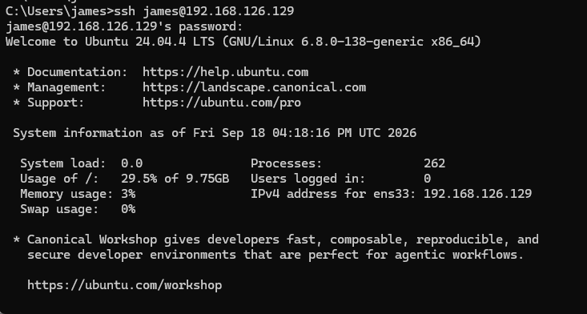
Made another executeable for collect evidence 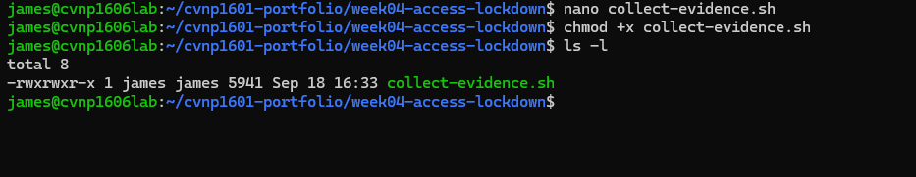

Made a group for auditors and added permissions 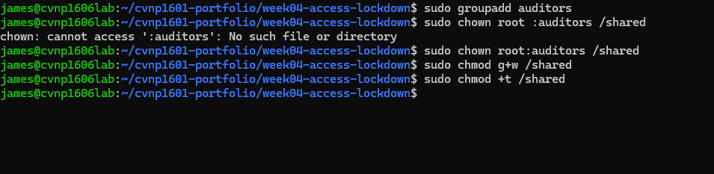
Added users and set up acl 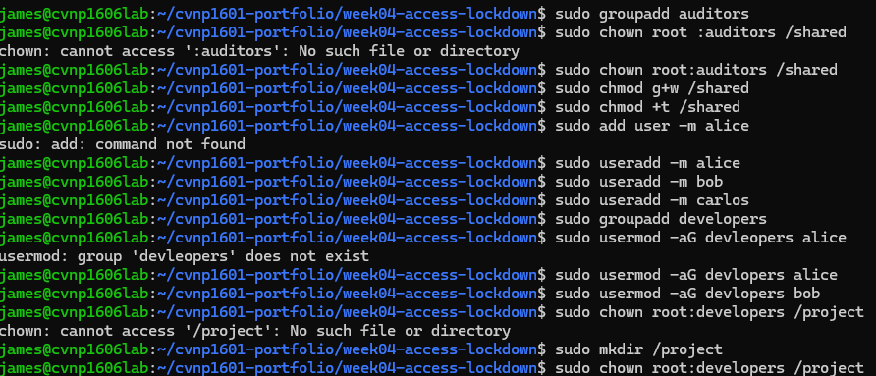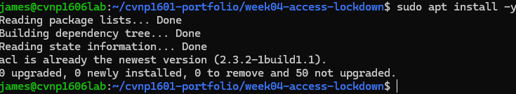
Ran a id on alice then shown the / directory 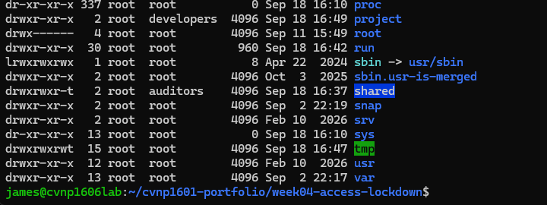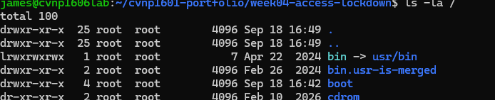
Made a permissions audit 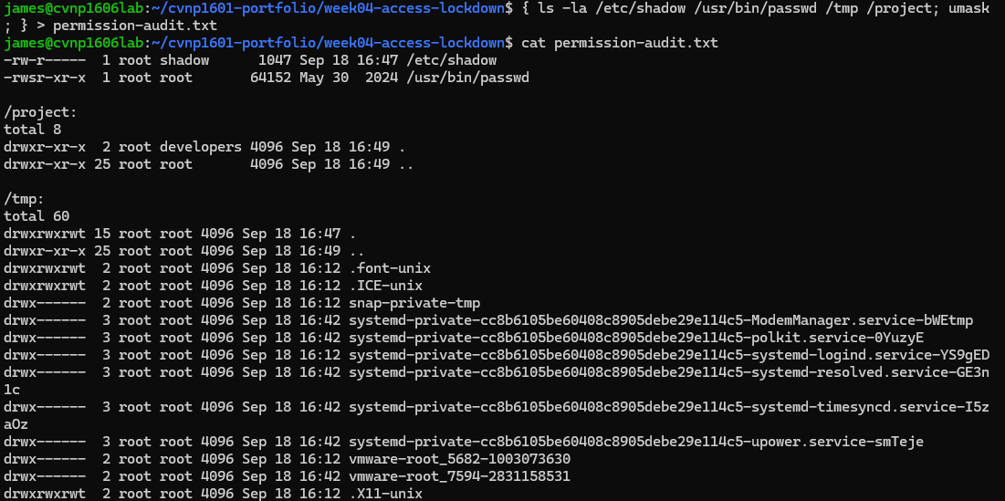/etc/shadow Owned by root and protected so regular users cannot read or change password information.
/usr/bin/passwd Has the SUID bit s, allowing the command to run with root privileges when users change their passwords.
/project Owned by root and assigned to the developers group. Developers can read and enter the directory but cannot modify its contents.
/tmp Allows everyone to read, write, and enter the directory. The sticky bit t prevents users from deleting files belonging to other users.

Before and after 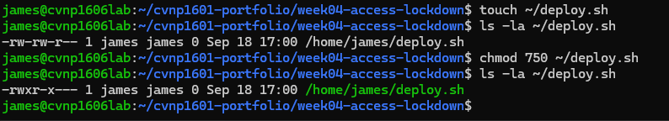
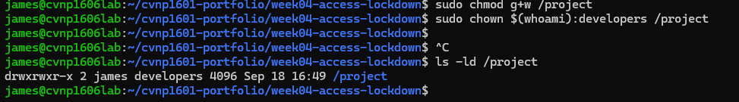
Octal 750 is owner can do everything, the group can read and execute, and everyone else has no access.
Added sticky bit to shared 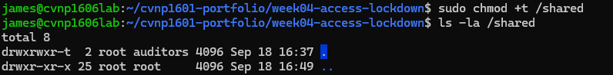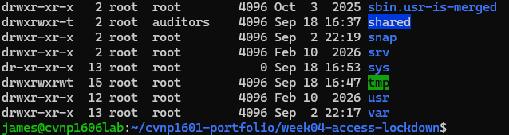made password and logged in as bob and failed to modifiy the project.txt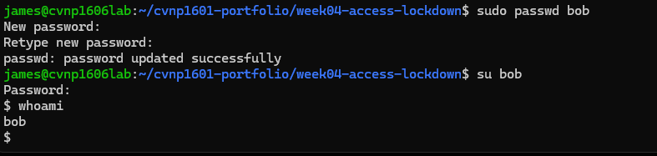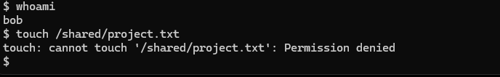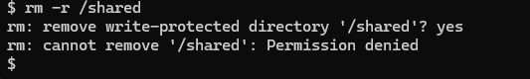
Permissions before loggining in as alice 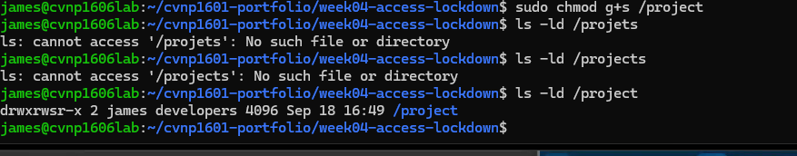
So I couldn’t get it to write in nano or vim before and after the commands any feed back why would be great

Set all facl permissions for carlos
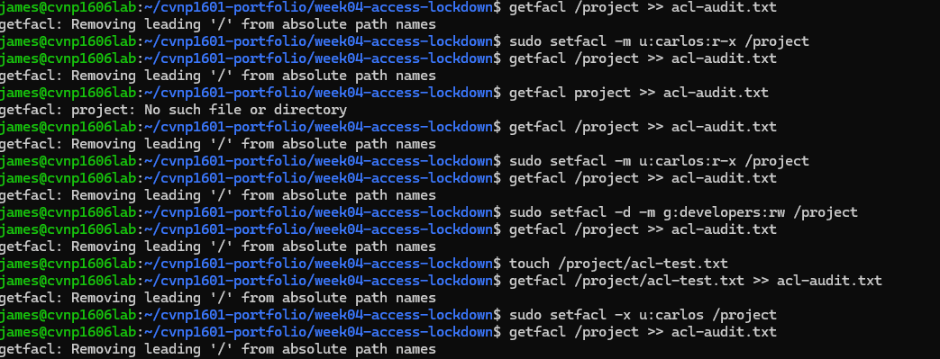
Made the acl test document 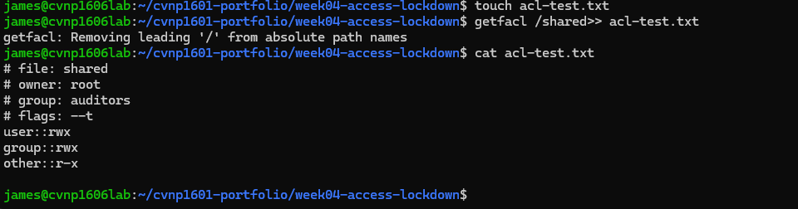
Made a git commit 